Rail bridge with guide sheets
Layout
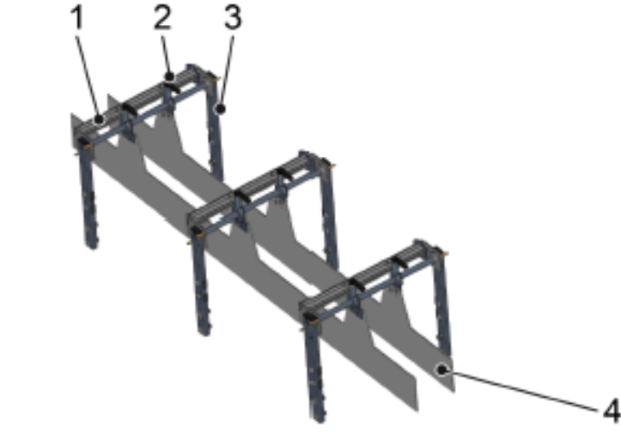

Figure 3-1: Guide rail

Nº | Description
1 | Axis
2 | Fastening
3 | Frame
4 | Guide rail

Function
The guide rail guides and stabilizes the material for processing during transport.
The guide rails are secured on the axles using fastenings. The axles are secured by the supports on the conveyor frame.
Two guide rails act as lateral guides for one lane.

